**PROJECT ON**

**NEW PROJECT LTD**

**NIIT**

**NEW PROJECT LTD**

**Batch Code:**

**Start Date: End Date:**

**Name of the Coordinator: Mrs. Titi Martins.**

**Name of Developers: Razak Ibrahim, Emmanuel Okundaye Salihu, Egbewumi Oluwapelumi, Inuwa Hauwa Walida, and Chukwu Fortune.**

**Date of Submission: 15 April 2019**

**NIIT**

**CERTIFICATE**

This is to certify that this report titled embodies the original work done by Emmanuel Okundaye Salihu, Egbewumi Oluwapelumi, Inuwa Hauwa Walida, and Chukwu Fortune in partial fulfillment of their course requirement at NIIT.

Coordinator: Mrs. Titi Martins

**ACKNOWLEDGEMENT**

**We have benefited a lot from the feedback and suggestions given to us by Mrs. Titi Martins**

**SYSTEM ANALYSIS**

**System Summary**: New Project LTD is a company that provides professional staff for different kind of contract projects. They distribute Time Cards to all their Employees on a daily basis, to have a record of all work duties performed. Due to the various kind of contract projects performed, the company stores a file of all the different kind of work duties performed by all their employees in the Work Details file. When a client requests for a project from the company, there are various parameters that will affect the project execution before a bill will be sent to the client for the outstanding payment.

**ENTITIES**

**Number of entities: 7**

**Name of entities:**

1. **Client**
2. **Project**
3. **Payment**
4. **Employee**
5. **Time card**
6. **Work details**
7. **Time card expenses**

**ATTRIBUTES**

Attributes:

The various entities and their attributes are listed in the following table.

|  |  |
| --- | --- |
| **Entity** | **Attributes** |
| Client | Client code  Country  Company name  Address  Phone  Contact Person |
| Project | Project Code  Project Description  Project Name  Estimate Bill  Start Date  End Date |
| Payment | Payment Code  Payment Amount  Payment Date  Payment Mode ID  Payment Mode Name  Project Code  Credit Card Number  Cardholder’s Name  Credit Card Expiry Date |
| Time card | Time Card ID  Billed Hours  Billing Rate  Project Code  Employee ID  Date Issued  Work Code ID |
| Employee | Employee Code  Employee Name  Address  Country  Work Phone  Billing Rate |

|  |  |
| --- | --- |
| **Entity** | **Attributes** |
| Time card expenses | Time Card ID  Expense Code ID  Expense Description  Expense Code  Expense Date  Expense Amount |
| Work details | Work Code ID  Work Code  Work Description  Work Date  Project Code |

**E/R DIAGRAM**

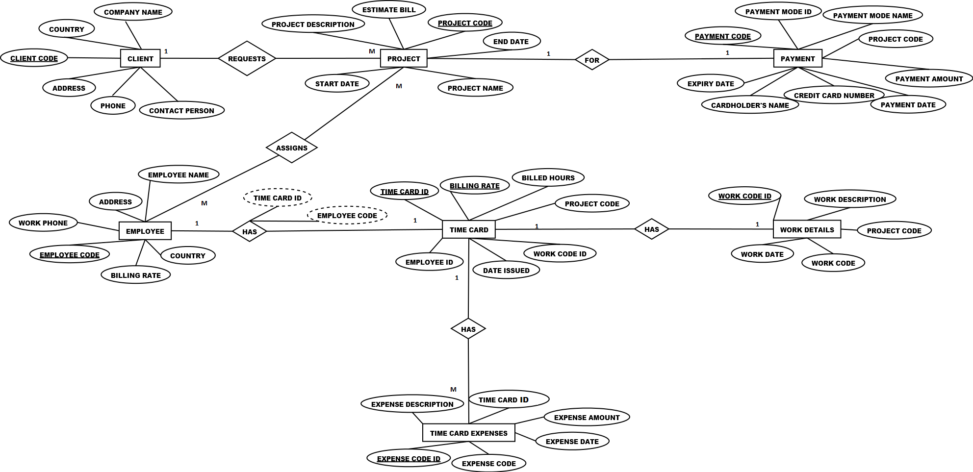

**TABLES**

Numbers of Tables: 8

Structure of Tables: The table structures are shown here.

|  |
| --- |
| **CLIENT** |
| CLIENT CODE |
| COMPANY NAME |
| ADDRESS |
| COUNTRY |
| CONTACT PERSON |
| PHONE |

|  |
| --- |
| **PROJECT** |
| PROJECT CODE |
| PROJECT NAME |
| PROJECT DESCRIPTION |
| ESTIMATE BILL |
| START DATE |
| END DATE |

|  |
| --- |
| **PAYMENT** |
| PAYMENT CODE |
| PAYMENT MODE ID |
| PAYMENT MODE NAME |
| PROJECT CODE |
| PAYMENT AMOUNT |
| PAYMENT DATE |
| CREDIT CARD NUMBER |
| CARDHOLDER’S NAME |
| EXPIRY DATE |

|  |
| --- |
| **TIME CARD** |
| TIME CARD ID |
| BILLED HOURS |
| BILLING RATE |
| PROJECT CODE |
| EMPLOYEE ID |
| DATE ISSUED |
| WORK CODE ID |

|  |
| --- |
| **TIME CARD EXPENSES** |
| TIME CARD ID |
| EXPENSE CODE ID |
| EXPENSE DESCRIPTION |
| EXPENSE CODE |
| EXPENSE DATE |
| EXPENSE AMOUNT |

|  |
| --- |
| **EMPLOYEE** |
| EMPLOYEE CODE |
| EMPLOYEE NAME |
| ADDRESS |
| COUNTRY |
| WORK PHONE |
| BILLING RATE |

|  |
| --- |
| RELATIONSHIP – TIME CARD DETAILS |

|  |
| --- |
| TIME CARD DETAILS |
| TIME CARD CODE |
| EMPLOYEE CODE |

|  |
| --- |
| **WORK DETAILS** |
| WORK CODE ID |
| WORK CODE |
| WORK DESCRIPTION |
| WORK DATE |
| PROJECT CODE |

**TABLES AFTER 1 NF**

The tables are already in 1NF. The table structures are shown here.

|  |
| --- |
| **CLIENT** |
| CLIENT CODE |
| COMPANY NAME |
| ADDRESS |
| COUNTRY |
| CONTACT PERSON |
| PHONE |

|  |
| --- |
| **PROJECT** |
| PROJECT CODE |
| PROJECT NAME |
| PROJECT DESCRIPTION |
| ESTIMATE BILL |
| START DATE |
| END DATE |

|  |
| --- |
| **PAYMENT** |
| PAYMENT CODE |
| PAYMENT MODE ID |
| PAYMENT MODE NAME |
| PROJECT CODE |
| PAYMENT AMOUNT |
| PAYMENT DATE |
| CREDIT CARD NUMBER |
| CARDHOLDER’S NAME |
| EXPIRY DATE |

|  |
| --- |
| **TIME CARD** |
| TIME CARD ID |
| BILLED HOURS |
| BILLING RATE |
| PROJECT CODE |
| EMPLOYEE ID |
| DATE ISSUED |
| WORK CODE ID |

|  |
| --- |
| **TIME CARD EXPENSES** |
| TIME CARD ID |
| EXPENSE CODE ID |
| EXPENSE DESCRIPTION |
| EXPENSE CODE |
| EXPENSE DATE |
| EXPENSE AMOUNT |

|  |
| --- |
| **EMPLOYEE** |
| EMPLOYEE CODE |
| EMPLOYEE NAME |
| ADDRESS |
| COUNTRY |
| WORK PHONE |
| BILLING RATE |

|  |
| --- |
| RELATIONSHIP – TIME CARD DETAILS |

|  |
| --- |
| TIME CARD DETAILS |
| TIME CARD CODE |
| EMPLOYEE CODE |

|  |
| --- |
| **WORK DETAILS** |
| WORK CODE ID |
| WORK CODE |
| WORK DESCRIPTION |
| WORK DATE |
| PROJECT CODE |

**TABLES AFTER 2 NF**

The tables are already in 2 NF as the attributes in each table depend on the primary key. The table structures are shown here.

|  |
| --- |
| **CLIENT** |
| CLIENT CODE |
| COMPANY NAME |
| ADDRESS |
| COUNTRY |
| CONTACT PERSON |
| PHONE |

|  |
| --- |
| **PROJECT** |
| PROJECT CODE |
| PROJECT NAME |
| PROJECT DESCRIPTION |
| ESTIMATE BILL |
| START DATE |
| END DATE |

|  |
| --- |
| **PAYMENT** |
| PAYMENT CODE |
| PAYMENT MODE ID |
| PAYMENT MODE NAME |
| PROJECT CODE |
| PAYMENT AMOUNT |
| PAYMENT DATE |
| CREDIT CARD NUMBER |
| CARDHOLDER’S NAME |
| EXPIRY DATE |

|  |
| --- |
| **TIME CARD** |
| TIME CARD ID |
| BILLED HOURS |
| BILLING RATE |
| PROJECT CODE |
| EMPLOYEE ID |
| DATE ISSUED |
| WORK CODE ID |

|  |
| --- |
| **TIME CARD EXPENSES** |
| TIME CARD ID |
| EXPENSE CODE ID |
| EXPENSE DESCRIPTION |
| EXPENSE CODE |
| EXPENSE DATE |
| EXPENSE AMOUNT |

|  |
| --- |
| **EMPLOYEE** |
| EMPLOYEE CODE |
| EMPLOYEE NAME |
| ADDRESS |
| COUNTRY |
| WORK PHONE |
| BILLING RATE |

|  |
| --- |
| RELATIONSHIP – TIME CARD DETAILS |

|  |
| --- |
| TIME CARD DETAILS |
| TIME CARD CODE |
| EMPLOYEE CODE |

|  |
| --- |
| **WORK DETAILS** |
| WORK CODE ID |
| WORK CODE |
| WORK DESCRIPTION |
| WORK DATE |
| PROJECT CODE |

**TABLES AFTER 3 NF**

|  |
| --- |
| **Credit Card Details** |
| Credit Card Number |
| Cardholder’s Name |
| Expiry Date |

In order for the tables to be in 3 NF we have to remove all transition dependencies. In the Payment table the attribute Payment Mode Name depends on Payment Mode ID instead of Payment Code. Therefore, we need to create another table Payment Modes. Likewise, Card holder’s Name and Expiry Date depends on Credit Card Number instead of Payment. Therefore, we create another table Credit Card Details. Lastly, in the table Time Card, Billed Hours depends on Billing Rate instead of Time Card ID. Therefore, we create another table Bill Section.

|  |
| --- |
| **CLIENT** |
| CLIENT CODE |
| COMPANY NAME |
| ADDRESS |
| COUNTRY |
| CONTACT PERSON |
| PHONE |

|  |
| --- |
| **PROJECT** |
| PROJECT CODE |
| PROJECT NAME |
| PROJECT DESCRIPTION |
| ESTIMATE BILL |
| START DATE |
| END DATE |

|  |
| --- |
| **PAYMENT** |
| PAYMENT CODE |
| PROJECT CODE |
| PAYMENT AMOUNT |
| PAYMENT DATE |
| CREDIT CARD NUMBER |
| Payment Mode ID |

|  |
| --- |
| **TIME CARD** |
| TIME CARD ID |
| BILLING RATE |
| PROJECT CODE |
| EMPLOYEE ID |
| DATE ISSUED |
| WORK CODE ID |

|  |
| --- |
| **Payment Modes** |
| Payment Mode ID |
| Payment Mode Name |

|  |
| --- |
| **TIME CARD EXPENSES** |
| TIME CARD ID |
| EXPENSE CODE ID |
| EXPENSE DESCRIPTION |
| EXPENSE CODE |
| EXPENSE DATE |
| EXPENSE AMOUNT |

|  |
| --- |
| **EMPLOYEE** |
| EMPLOYEE CODE |
| EMPLOYEE NAME |
| ADDRESS |
| COUNTRY |
| WORK PHONE |
| BILLING RATE |

|  |
| --- |
| **WORK DETAILS** |
| WORK CODE ID |
| WORK CODE |
| WORK DESCRIPTION |
| WORK DATE |
| PROJECT CODE |

|  |
| --- |
| RELATIONSHIP – TIME CARD DETAILS |

|  |
| --- |
| TIME CARD DETAILS |
| TIME CARD CODE |
| EMPLOYEE CODE |

|  |
| --- |
| **BILL SECTION** |
| BILLING RATE |
| BILLED HOURS |

**PRIMARY AND FOREIGN KEYS**

* **CLIENT**
  + **PRIMARY KEY: CLIENT CODE**
* **PROJECT**
  + **PRIMARY KEY: PROJECT CODE**
* **PAYMENT**
  + **PRIMARY KEY: PAYMENT CODE**
* **EMPLOYEE**
  + **PRIMARY KEY: EMPLOYEE CODE**
  + **FOREIGN KEY: BILLING RATE**
* **TIME CARD DETAILS**
  + **DERIVED KEYS: TIME CARD ID AND EMPLOYEE ID**
* **TIME CARD**
  + **PRIMARY KEY: TIME CARD ID and BILLING RATE**
  + **FOREIGN KEY: EMPLOYEE ID, WORK CODE ID AND PROJECT CODE**
* **WORK DETAILS**
  + **PRIMARY KEY: WORK CODE ID**
  + **FOREIGN KEY: PROJECT CODE**
* **TIME CARD EXPENSES**
  + **PRIMARY KEY: EXPENSE CODE ID**
  + **FOREIGN KEY: TIME CARD ID**

**RELATIONSHIP BETWEEN FINAL TABLES**

|  |
| --- |
| **CLIENT** |
| CLIENT CODE |
| COMPANY NAME |
| ADDRESS |
| COUNTRY |
| CONTACT PERSON |
| PHONE |

|  |
| --- |
| **PROJECT** |
| PROJECT CODE |
| PROJECT NAME |
| PROJECT DESCRIPTION |
| ESTIMATE BILL |
| START DATE |
| END DATE |

|  |
| --- |
| **WORK DETAILS** |
| WORK CODE ID |
| WORK CODE |
| WORK DESCRIPTION |
| WORK DATE |
| PROJECT CODE |

|  |
| --- |
| **PAYMENT** |
| PAYMENT CODE |
| PROJECT CODE |
| PAYMENT AMOUNT |
| PAYMENT DATE |
| CREDIT CARD NUMBER |

|  |
| --- |
| CARDHOLDER’S NAME |
| EXPIRY DATE |

|  |
| --- |
| **BILL SECTION** |
| BILLING RATE |
| BILLED HOURS |

|  |
| --- |
| **TIME CARD** |
| TIME CARD ID |
| BILLING RATE |
| PROJECT CODE |
| EMPLOYEE ID |
| DATE ISSUED |
| WORK CODE ID |

|  |
| --- |
| **EMPLOYEE** |
| EMPLOYEE CODE |
| EMPLOYEE NAME |
| ADDRESS |
| COUNTRY |
| WORK PHONE |
| BILLING RATE |

|  |
| --- |
| **Payment Modes** |
| Payment Mode ID |
| Payment Mode Name |

|  |
| --- |
| TIME CARD DETAILS |
| TIME CARD CODE |
| EMPLOYEE CODE |

|  |
| --- |
| **TIME CARD EXPENSES** |
| TIME CARD ID |
| EXPENSE CODE ID |
| EXPENSE DESCRIPTION |
| EXPENSE CODE |
| EXPENSE DATE |
| EXPENSE AMOUNT |